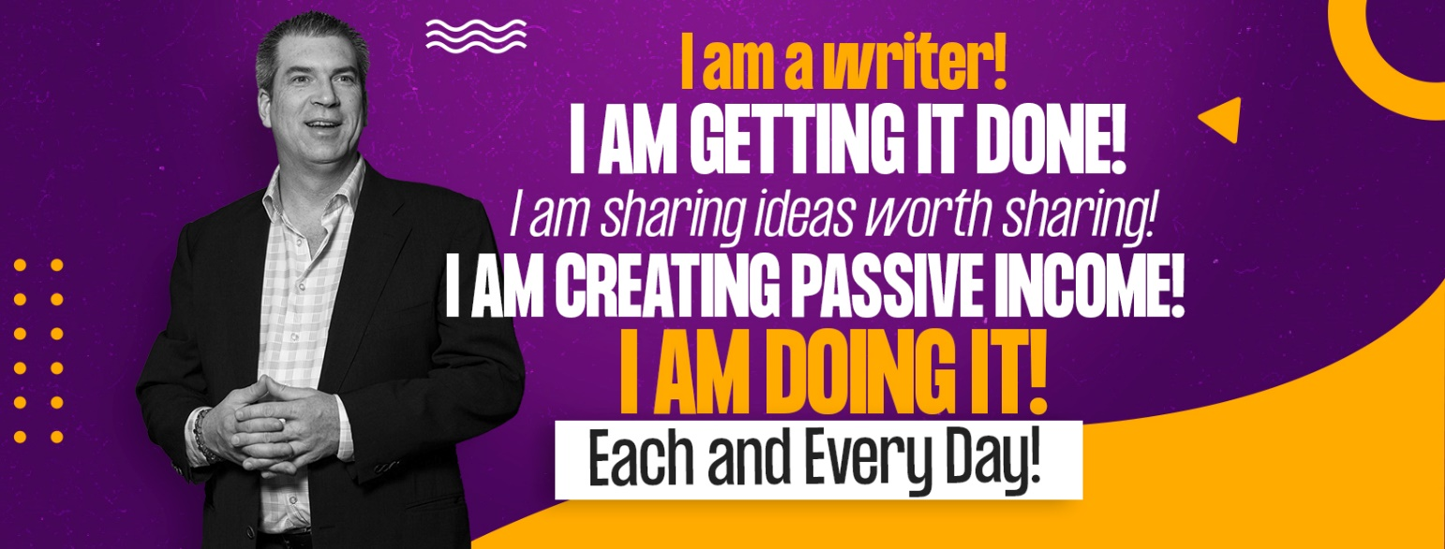

TWELVE WEEK BOOK
THIRD CHAPTER NON-FICTION BOOK GENERATOR

Congratulations! You made it to chapter three. There is no stopping you now. If you have followed my outline strategies to this point, you will be excited to know that after you complete this third chapter, the book will practically write itself! Why? Because this third chapter will follow a listicle format (a list that is an article), and then each successive chapter will be based on the items in the list. In my book, The Seven Most Effective Methods of Self-Hypnosis, I wrote a chapter outlining each of the strategies, and the next seven chapters were then the breakdown and how-to of each of these techniques.

Most listicles have six to twelve key points. Less than that, and the book will be very short, more than that, and it can seem overwhelming. But there are exceptions to that. Robert Greene wrote The 48 Laws of Power (a New York Times bestseller). Another best seller was The 4 Disciplines of Execution. You can do what you want to construct your listicle, and you can organize your book around any number (and I recommend seven to twelve), but seven does seem to be a popular count. The best example of this is the bestselling book The 7 Habits of Highly Effective People, one of the bestselling business and personal development books of all time. Dr. John Gottman wrote one of the bestselling relationship books, The Seven Principles for Making a Marriage Work. In many ways, seven is a magic number.

I want you to note that you do not have to use the number of points in your listicle in your book’s title or subtitle, even though the examples above do. You may have a better idea for a title and subtitle, but at the same time, you might consider it for the title if it makes sense for you.

Let’s look now at the elements of this important chapter. You will begin with an introduction, introducing solutions to the issues in chapter two. It is nice to refer back to the promises, relating the solutions you will be offering to the attainment of the promises.

The middle section of this chapter is the larges and is your listicle. To write a listicle, think of how you would concisely summarize the key solutions you will offer in your book. This is the list component of your listicle. For example, if you are writing a book about managing anxiety, one of the solutions might be teaching people to take control of their physical state through deep breathing. Maybe you can come up with a catchy name for that. That should be your listicle bullet point. In this example, I might teach someone to breathe in a four-count breath and exhale a six-count breath. Maybe I will have them count to eight between breaths, using autosuggestion or affirmation. I might decide a catchy name for this is The 4-6-8 Technique. Then in the next couple of paragraphs, I might introduce the idea.

The paragraphs (the article part of a listicle) that follow each subtitle introduce the idea. They provide enough to introduce the idea and encourage the reader with real solutions, but you do not need to explain it all, defend the idea, or write much more than a concrete description of the idea.

If you have seven key solutions in your book to overcome the problems in chapter two and to meet the goal of the thesis in chapter one, writing a couple of short paragraphs for each will create a nice fat chapter.

The end of the listicle is then a call to action. This will be the final paragraph where you invite the reader to dive deeper. The rest of the book is then that deep dive into each item on the listicle. At this point, by finishing chapter three, your book is on autopilot and will be easy to finish.

Introduction paragraph:

In this paragraph, you will promise the reader that there are great solutions despite the difficulties presented in chapter two. You could share some facts or statistics showing that people can experience something different or make change. In my book Turn Around Trauma, I shared that children with adverse childhood experiences could, when taught mindfulness, decrease the adverse outcomes often associated with the problem. I quoted a journal article on teaching children mindfulness who come from backgrounds with many adverse childhood experiences (ACEs).

You could also begin this with a personal testimony or story or share the success of those you have worked with. Although there are many ways to begin this chapter, the first two paragraphs should focus on hope and the ability to transcend the roadblocks in chapter two.

Another way to begin this chapter is by speaking directly to the reader. You can type questions and answer them conversationally as if you were sitting across from somebody at a coffee shop.

Create your opening paragraph here that illustrates solutions that are possible:
____________________________________________________________________________________________________________________________________________________________________________________________________________________________________________________________________________________________________________________________________________________________________________________________________________________________________________________________________________________________________________________________________________________________________________________________________________________________________________________________________________________________________________________________________________________________________________________________________________________________________________________________________________________________________________________________________________________________________________________________________________________________________________________________________________________________________________________________________
The second paragraph should directly reference the listicle that will follow. Tell the reader that in your personal experience, or from your professional research, or from studies in your topic that specific solutions or ideas exist and that you will be articulating them. Refer back to the promises in chapter one and assure them that good things will come by taking action.
__________________________________________________________________________________________________________________________________________________________________________________________________________________________________________________________________________________________________________________________________________________________________________________________________________________________________________________________________________________________________________________________________________________________________________________________________________________________________________________________________________________________________________________________________________________________________________________________________________________________________________________________________________________________________________________________________________________________________________________________________________________________________________________________________________________________________________________________________________________________________________________________________________________________________________________________________________________________________________________________

Listicle:

You now have seven to twelve solutions, ideas, methods, skills, learnings, or truths that your book will reveal as the pathway to overcoming the difficulty in chapter two. List each of those, and then write two or three short paragraphs introducing and explaining the key characteristics of each. Again, you do not need to defend them, explain everything, or go too deep into the topics. You will have chapters later than do that. I am creating a template that will allow you to do seven of these, but you can simply edit your final document and add in more if you want to.

Bullet Point One:
____________________________________________________________________________________________________________________________________________________________________________________________________________________________________________________________________________________________________________________________________________________________________________

Paragraph One:
_________________________________________________________________________________________________________________________________________________________________________________________________________________________________________________________________________________________________________________________________________________________________________________________________________________________________________

Paragraph Two:
_________________________________________________________________________________________________________________________________________________________________________________________________________________________________________________________________________________________________________________________________________________________________________________________________________________________________________
Bullet Point Two:
___________________________________________________________________________________________________________________________________________________________________________________________________________________________________________________________________________________________________________________________________________________________________________________________________________________________________________________

Paragraph One:
______________________________________________________________________________________________________________________________________________________________________________________________________________________________________________________________________________________________________________________________________________________________________________________________________________________________________________________________________________________________________

Paragraph Two:
______________________________________________________________________________________________________________________________________________________________________________________________________________________________________________________________________________________________________________________________________________________________________________________________________________________________________________________________________________________________________

Bullet Point Three:
___________________________________________________________________________________________________________________________________________________________________________________________________________________________________________________________________________________________________________________________________________________________________________________________________________________________________________________

Paragraph One:
______________________________________________________________________________________________________________________________________________________________________________________________________________________________________________________________________________________________________________________________________________________________________________________________________________________________________________________________________________________________________

Paragraph Two:
______________________________________________________________________________________________________________________________________________________________________________________________________________________________________________________________________________________________________________________________________________________________________________________________________________________________________________________________________________________________________
Bullet Point Four:
___________________________________________________________________________________________________________________________________________________________________________________________________________________________________________________________________________________________________________________________________________________________________________________________________________________________________________________

Paragraph One:
______________________________________________________________________________________________________________________________________________________________________________________________________________________________________________________________________________________________________________________________________________________________________________________________________________________________________________________________________________________________________

Paragraph Two:
______________________________________________________________________________________________________________________________________________________________________________________________________________________________________________________________________________________________________________________________________________________________________________________________________________________________________________________________________________________________________

Bullet Point Five:
___________________________________________________________________________________________________________________________________________________________________________________________________________________________________________________________________________________________________________________________________________________________________________________________________________________________________________________

Paragraph One:
______________________________________________________________________________________________________________________________________________________________________________________________________________________________________________________________________________________________________________________________________________________________________________________________________________________________________________________________________________________________________

Paragraph Two:
______________________________________________________________________________________________________________________________________________________________________________________________________________________________________________________________________________________________________________________________________________________________________________________________________________________________________________________________________________________________________
Bullet Point Six:
___________________________________________________________________________________________________________________________________________________________________________________________________________________________________________________________________________________________________________________________________________________________________________________________________________________________________________________

Paragraph One:
______________________________________________________________________________________________________________________________________________________________________________________________________________________________________________________________________________________________________________________________________________________________________________________________________________________________________________________________________________________________________

Paragraph Two:
______________________________________________________________________________________________________________________________________________________________________________________________________________________________________________________________________________________________________________________________________________________________________________________________________________________________________________________________________________________________________

Bullet Point Seven:
___________________________________________________________________________________________________________________________________________________________________________________________________________________________________________________________________________________________________________________________________________________________________________________________________________________________________________________

Paragraph One:
______________________________________________________________________________________________________________________________________________________________________________________________________________________________________________________________________________________________________________________________________________________________________________________________________________________________________________________________________________________________________

Paragraph Two:
______________________________________________________________________________________________________________________________________________________________________________________________________________________________________________________________________________________________________________________________________________________________________________________________________________________________________________________________________________________________________
Conclusion paragraph 1:
___________________________________________________________________________________________________________________________________________________________________________________________________________________________________________________________________________________________________________________________________________________________________________________________________________________________________________________________________________________________________________________________________________________________________________________________________________________________________________________________________________________________________________________________________________________________________________________________________________________________________________________
_______________________________________________________________________________________________________________________________________________________________________________________________________________________________________________________________________________________________________________________________________________________________________________________________________________________________________________________________________
____________________________________________________________________________________________________________________________________________________________________________________________________________________________________________________________________________________________________________________________________________________________________________
_________________________________________________________________________________________________________________________________________________________________________________________________________________________________________________________________________________

Conclusion paragraph 2:
____________________________________________________________________________________________________________________________________________________________________________________________________________________________________________________________________________________________________________________________________________________________________________
____________________________________________________________________________________________________________________________________________________________________________________________________________________________________________________________________________________________________________________________________________________________________________
_______________________________________________________________________________________________________________________________________________________________________________________________________________________________________________________________________________________________________________________________________________________________________________________________________________________________________________________________________
_______________________________________________________________________________________________________________________________________________________________________________________________________________________________________________________________________________________________________________________________________________________________________________________________________________________________________________________________________
__________________________________________________________________________________________________________________________________________________________________________________________________________________________________________________________________________________________________________________________________________________________________________________________________________________________________________________________________________________________________________________________________________________________________

