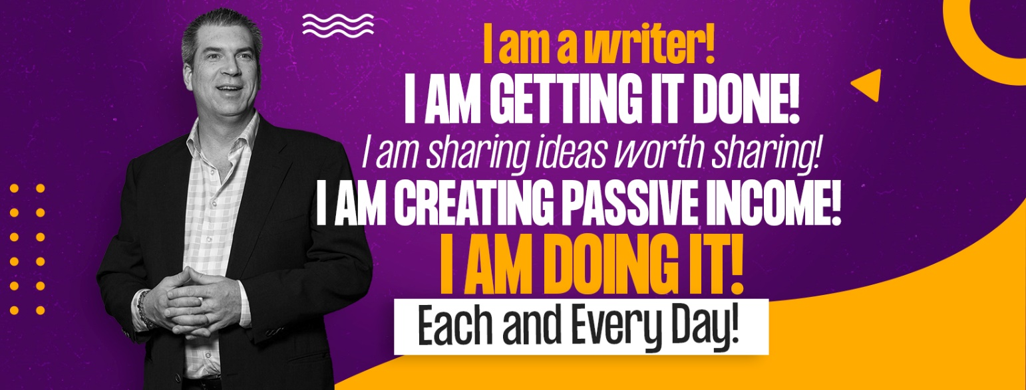

TWELVE WEEK BOOK
TWELVE CHAPTER NON-FICTION BOOK GENERATOR

The purpose of the last chapter of your book is not a summary, it is an exhortation to the reader to take the learnings, emotions, and ideas from the previous chapter and carry them into their own life. In order to make the most impact, you should focus on the theme of the book and tie up any loose ends. Leave your reader with a call to action that will inspire them to change their life for the better.

Your book is a guide to change, so don’t let your reader put it down until they are inspired to do just that. Thank them for accompanying you on your journey and remind them of the difference they can make in the world.

The last chapter of your book does not have to be long. It might even be the shortest chapter of your book. But it will be the most important. Make sure you take your time and make it count.

Your book probably taught how-to skills, had stories that served as inspiration and application and guided the reader from the problem to a solution. You can use this outline to create an awesome last chapter:

1.) Begin with a reminder of the problem that brought them to read the book in the first place. Remind the reader of where they have been. Speak directly to the reader in your first paragraph telling them, "When you first picked up this book you wondered..." Write your first paragraph here:
______________________________________________________________________________________________________________________________________________________________________________________________________________________________________________________________________________________________________________________________________________________________________________________________________________________________________________________________________________________________________________________________________________________________________________________________________________________________________________________________________________________________________________________________________________________________________________________________________________________________________________________________________________________________________________________________________________

2.) The reader was promised something at the end of chapter one. Write a paragraph telling the reader that by taking action on the previous chapters, they will manifest those promises. Review the promises, making sure the reader knows that through action, the promises materialize:
__________________________________________________________________________________________________________________________________________________________________________________________________________________________________________________________________________________________________________________________________________________________________________________________________________________________________________________________________________________________________________________________________________________________________________________________________________________________________________________________________________________________________________________________________________________________________________________________________________________________________________________________________________________________________________________________________________________________________________________________________________________________________________________________________________________________________________________________________________________________________________________________________________________________________________________________________________________________________________________________

3.) Share a story. Your own story or another, where the promises coming to life is illustrated:
__________________________________________________________________________________________________________________________________________________________________________________________________________________________________________________________________________________________________________________________________________________________________________________________________________________________________________________________________________________________________________________________________________________________________________________________________________________________________________________________________________________________________________________________________________________________________________________________________________________________________________________________________________________________________________________________________________________________________________________________________________________________________________________________________________________________________________________________________________________________________________________________________________________________________________________________________________________________________________________________

4.) Write a short synopsis of the big picture action steps that come from the previous pages:
__________________________________________________________________________________________________________________________________________________________________________________________________________________________________________________________________________________________________________________________________________________________________________________________________________________________________________________________________________________________________________________________________________________________________________________________________________________________________________________________________________________________________________________________________________________________________________________________________________________________________________________________________________________________________________________________________________________________________________________________________________________________________________________________________________________________________________________________________________________________________________________________________________________________________________________________________________________________________________________________

5.) Write a paragraph telling the reader how they can put this into action.
_______________________________________________________________________________________________________________________________________________________________________________________________________________________________________________________________________________________________________________________________________________________________________________________________________________________________________________________________________________________________________________________________________________________________________________________________________________________________________________________________________________________________________________________________________________________________________________________________________________________________________________________________________________________________________________________________________________________________________________________________________________________________________________________________________________________________________________________________________________________________________________________________________________________________
6.) End a positive note, with a final paragraph with affirmations for the reader's intentions and abilities.
_______________________________________________________________________________________________________________________________________________________________________________________________________________________________________________________________________________________________________________________________________________________________________________________________________________________________________________________________________________________________________________________________________________________________________________________________________________________________________________________________________________________________________________________________________________________________________________________________________________________________________________________________________________________________________________________________________________________________________________________________________________________________________________________________________________________________________________________________________________________________________________________________________________________________

7.) You can have a final paragraph or post-script that points them to your website, your services, or other ways to reach out to you for continued learning, to other books you have written, coaching services you provide, speaking, or other services you offer. If you have an optin on your website, do not forget to tell them to go get it!
____________________________________________________________________________________________________________________________________________________________________________________________________________________________________________________________________________________________________________________________________________________________________________________________________________________________________________________________________________________________________________________________________________________________________________________________________________________________________________________________________________________________________________________________________________________________________________________________________________________________________________________________________________________________________________________________________________________________________________________________________________________________________________________________________________________________________________________________________

